# Second Year B. Tech (EL & CE)

**Semester: IV Subject:** Basic IoT Laboratory

**Name: Shreerang Mhatre Class: SY**

**Roll No: 29 Batch: A2**

# Experiment No: 06

**Name of the Experiment**: **Understanding Raspberry-Pi as single board Computer and exploring GPIO.**

**Performed on: 15/03/2023**

**Teacher’s Signature with date**

**Marks**

**Submitted on: 19/03/2023**

**Aim:** Understanding Raspberry-Pi as single board Computer and exploring GPIO.

**Prerequisite:** Basics of Raspberry Pi.

.

# Objective:

1. Understand basics of Raspberry Pi as single board computer
2. Understand the layout of Raspberry pi
3. Understand the GPIO pin out of Raspberry Pi

# Components and equipment required:

Raspberry Pi Board.

# Theory:

Raspberry Pis are single-board computers (SBCs), meaning the memory, interface as well as processor are soldered into one circuit board that numbers 4 revisions and a minimalistic zero variant. The pocket-size computers are built to make learning programming languages fun. Raspberry Pi is a series of SBCs developed in the United Kingdom by the Raspberry Pi Foundation in association with Broadcom. The Raspberry Pi project originally leaned towards the promotion of teaching basic computer science in schools and in developing countries. The original model became more popular than anticipated, selling outside its target market for uses such as robotics. It is widely used in many areas, such as for weather monitoring, because of its low cost, modularity, and open design. It is typically used by computer and electronic hobbyists, due to its adoption of HDMI and USB devices. The main difference between a Raspberry Pi (tiny computer) and other computers is the GPIO (General Purpose Input Output) pins. The GPIO pins are one way in which the Raspberry Pi can control and monitor the outside world by being connected to electronic circuits.

## Hardware

* A Raspberry Pi computer with an SD card or micro SD card
* A monitor with a cable (and, if needed, an HDMI adaptor)
* A USB keyboard and mouse
* A power supply
* Headphones or speakers (optional)
* An ethernet cable (optional)

## Software

Raspberry Pi OS, installed using the Raspberry Pi Imager

## Series and generations:

There are three series of Raspberry Pi, and several generations of each have been released. Raspberry Pi SBCs feature a Broadcom system on a chip (SoC) with an integrated ARM- compatible central processing unit (CPU) and on-chip graphics processing unit (GPU).

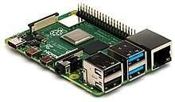

**Figure 6.1: Raspberry Pi 4 Model B**

## Raspberry Pi Family with specification

|  |  |  |  |  |  |  |  |  |  |
| --- | --- | --- | --- | --- | --- | --- | --- | --- | --- |
| **Family** | **Model** | **SoC** | **Memor y** | **Form Factor** | **Ethernet** | **Wirel ess** | **GPIO** | **Relea sed** | **Disco ntinu ed** |
| Raspberry Pi | B | BCM2835 | 256 MB | Standard | Yes | No | 26-pin | 2012 | Yes |
| Raspberry Pi | A | BCM2835 | 256 MB | Standard | No | No | 26-pin | 2013 | No |
| Raspberry Pi | B+ | BCM2835 | 512 MB | Standard | Yes | No | 40-pin | 2014 | No |
| Raspberry Pi | A+ | BCM2835 | 512 MB | Compact | No | No | 40-pin | 2014 | No |

|  |  |  |  |  |  |  |  |  |  |
| --- | --- | --- | --- | --- | --- | --- | --- | --- | --- |
| Raspberry Pi Zero | Zero | BCM2835 | 512 MB | Ultra- Compact | No | No | 40-pin | 2015 | No |
| Raspberry Pi 2 | B | BCM2836/7 | 1 GB | Standard | Yes | No | 40-pin | 2015 | No |
| Raspberry Pi 3 | B | BCM2837A0/ B0 | 1 GB | Standard | Yes | Yes | 40-pin | 2016 | No |
| Raspberry Pi Zero | W/W H | BCM2835 | 512 MB | Ultra- Compact | No | Yes | 40-pin | 2017 | No |
| Raspberry Pi 3 | A+ | BCM2837B0 | 512 MB | Compact | No | Yes  (dual band) | 40-pin | 2018 | No |
| Raspberry Pi 3 | B+ | BCM2837B0 | 1 GB | Standard[]](https://en.wikipedia.org/wiki/Raspberry_Pi) | Yes ([Gigabit](https://en.wikipedia.org/wiki/Gigabit_Ethernet) [Ethernet](https://en.wikipedia.org/wiki/Gigabit_Ethernet)) | Yes  (dual band) | 40-pin | 2018 | No |
| Raspberry Pi 4 | B | BCM2711 | 1 GB | Standard | Yes ([Gigabit](https://en.wikipedia.org/wiki/Gigabit_Ethernet) [Ethernet](https://en.wikipedia.org/wiki/Gigabit_Ethernet)) | Yes  (dual band) | 40-pin | 2019[[4](https://en.wikipedia.org/wiki/Raspberry_Pi)  [3]](https://en.wikipedia.org/wiki/Raspberry_Pi) | March 2020[[1]](https://en.wikipedia.org/wiki/Raspberry_Pi) |
| Raspberry Pi 4 | B | BCM2711 | 2 GB | Standard | Yes ([Gigabit](https://en.wikipedia.org/wiki/Gigabit_Ethernet) [Ethernet](https://en.wikipedia.org/wiki/Gigabit_Ethernet)) | Yes  (dual band) | 40-pin | 2019[[4](https://en.wikipedia.org/wiki/Raspberry_Pi)  [3]](https://en.wikipedia.org/wiki/Raspberry_Pi) | No |
| Raspberry Pi 4 | B | BCM2711 | 4 GB | Standard | Yes ([Gigabit](https://en.wikipedia.org/wiki/Gigabit_Ethernet) [Ethernet](https://en.wikipedia.org/wiki/Gigabit_Ethernet)) | Yes  (dual band) | 40-pin | 2019[[4](https://en.wikipedia.org/wiki/Raspberry_Pi)  [3]](https://en.wikipedia.org/wiki/Raspberry_Pi) | No |
| Raspberry Pi 4 | B | BCM2711 | 8 GB | Standard | Yes ([Gigabit](https://en.wikipedia.org/wiki/Gigabit_Ethernet) [Ethernet](https://en.wikipedia.org/wiki/Gigabit_Ethernet)) | Yes  (dual band) | 40-pin | 2020 | No |

|  |  |  |  |  |  |  |  |  |  |
| --- | --- | --- | --- | --- | --- | --- | --- | --- | --- |
| Raspberry Pi 4 | 400 | BCM2711 | 4 GB | Keyboard | Yes ([Gigabit](https://en.wikipedia.org/wiki/Gigabit_Ethernet) [Ethernet](https://en.wikipedia.org/wiki/Gigabit_Ethernet)) | Yes  (dual band) | 40-pin | 2020 | No |
| Raspberry Pi Pico | N/A | [RP2040](https://en.wikipedia.org/wiki/RP2040) | 264 KB | Pico  (21 mm ×  51 mm) | No | No | 26-pin | 2021 | ? |

The Pi can control LEDs, turning them on or off, drive motors, and interact with many other objects. It can also detect the pressing of a switch, change in temperature, or light, etc, by attaching kinds of sensors. These pins are a physical interface between the Raspberry Pi and the outside world. Using them, you can program the Raspberry Pi to switch devices on and off (output), or receive data from sensors and switches (input). Of the 40 pins, 26 are GPIO pins and the others are power or ground pins (plus two ID EEPROM pins which you should not play with unless you know your stuff!)

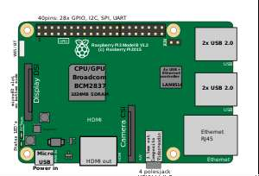

**Figure 6.2: Location of Connectors & main ICs on Raspberry Pi 3**

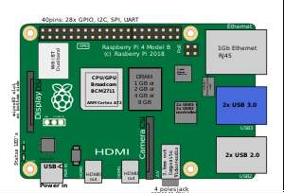

**Figure 6.3: Location of Connectors & main ICs on Raspberry Pi 4**

## General purpose input-output (GPIO) connector

Raspberry Pi 1 Models A+ and B+, Pi 2 Model B, Pi 3 Models A+, B and B+, Pi 4, and Pi Zero, Zero W, and Zero WH GPIO J8 have a 40-pin pinout. Raspberry Pi 1 Models A and B have only the first 26 pins.

In the Pi Zero and Zero W, the 40 GPIO pins are unpopulated, having the through-holes exposed for soldering instead. The Zero WH (Wireless + Header) has the header pins preinstalled.

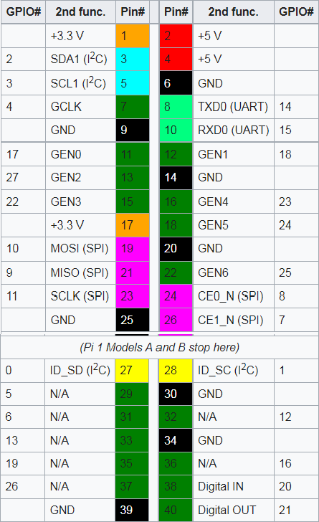

Model B rev. 2 also has a pad (called P5 on the board and P6 on the schematics) of 8 pins offering access to an additional 4 GPIO connections. These GPIO pins were freed when the four board version identification links present in revision 1.0 were removed.

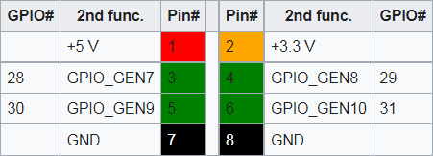

## Raspberry Pi Tutorial: Raspberry Pi Components

Now, let’s have a look at the different components of the Raspberry Pi 3 – B model:

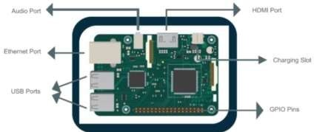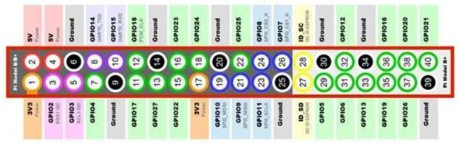

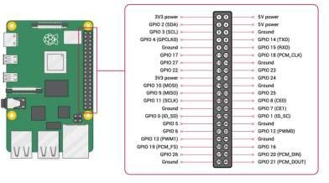

**Figure 6.4: GPIO Pinout Diagram**

**GPIO Functions**

Both the Raspberry Pi3 and Pi4 offer these functions:

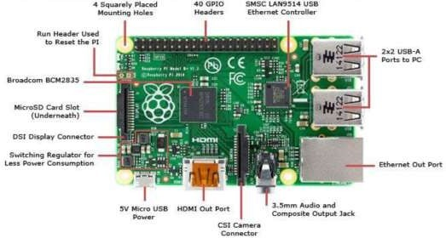

**Figure 6.5: Raspberry Pi Board Layout**

* **GPIO** is your standard pins that simply be used to turn devices on and off. For example, a LED.
* **I2C** (Inter-Integrated Circuit) pins allow you to connect and talk to hardware modules that support this protocol (I2C Protocol). This protocol will typically take up two pins. The GPIO 2 SDA and GPIO 3 SCL allow the connection via the I2C protocol. I2C creates a serial, synchronous communication with multiple server/client connection of up to 128 devices.
* **SPI** (Serial Peripheral Interface Bus) pins can be used to connect and talk to SPI devices. Pretty much the same as I2C but makes use of a different protocol. The SPI protocol is a synchronous serial communication between one server and several clients, where both can actively send data. To make an SPI outbound connection, 4 pins are needed. The Raspberry Pi allows to make either 2 separate Server connections, or one server, one client connections. For the 1st GPIO subsystem, GPIO 9, 19, 11, 8 and 16 are used, and for the 2nd GPIO subsystem its 19, 20, 21 and 16.
* **UART** (Universal asynchronous receiver/transmitter) is the serial pins used to communicate with other devices. GPIO 10 (RX) and GPIO 8 TX can be used to directly connect two devices with the UART protocol, which enables serial, asynchronous communication.
* **PWM:** Pulse width modulation is a signaling technique in which a digital signal is switching rapidly between two states high and low in a certain frequency. The Raspberry pi has no native support for PWM, but there are Libraries that provide Software PWM, although with restrictions compared to Arduino.
* **DNC** stands for do not connect, this is pretty self-explanatory.
* The **power** pins pull power directly from the Raspberry Pi.
* **GND** are the pins you use to ground your devices. It doesn’t matter which pin you use as they are all connected to the same line.

## Connect your Raspberry Pi

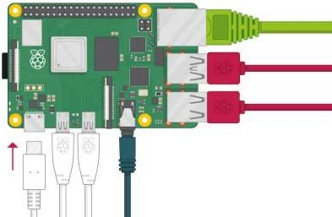

**Figure 6.6: Raspberry Pi Connectors**

* + Check the slot on the underside of your Raspberry Pi to see whether an SD card is inside. If no SD card is there, then insert an SD card with Raspbian installed (via NOOBS).
  + Find the USB connector end of your mouse’s cable, and connect the mouse to a USB port on your Raspberry Pi (it doesn’t matter which port you use).
  + Connect the keyboard in the same way.
  + Make sure your screen is plugged into a wall socket and switched on.
  + Look at the HDMI port(s) on your Raspberry Pi — notice that they have a flat side on top.
  + Use a cable to connect the screen to the Raspberry Pi’s HDMI port — use an adapter if necessary.
  + Connect your screen to the single HDMI port.
  + If you want to connect the Pi to the internet via Ethernet, use an Ethernet cable to connect the Ethernet port on the Raspberry Pi to an Ethernet socket on the wall or on your internet router. You don’t need to do this if you want to use wireless connectivity, or if you don’t want to connect to the internet.
  + If your screen has speakers, your Raspberry Pi can play sound through these. Or you could connect headphones or speakers to the audio port.
  + Plug the power supply into a socket and then connect it to your Raspberry Pi’s USB power port.
  + You should see a red light on your Raspberry Pi and raspberries on the monitor.



**Figure 6.7: Raspberry Pi Graphical Desktop**

* Your Raspberry Pi then boots up into a graphical desktop.

4M%veIGWi!ilnEsx

# Conclusion:

**Post Lab Questions:**

1. What is Raspberry Pi? How does it works?
2. What are the different components of the Raspberry Pi board?
3. How is Raspberry Pi used in IoT?
4. How is Raspberry pi different from Arduino and NodeMCU?

# Additional links for more information:

1. Raspberry Pi Documentation <https://www.raspberrypi.com/documentation/computers/os.html>
2. Getting Started with Raspberry Pi https://projects.raspberrypi.org/en/projects/raspberry-pi-getting-started/3
3. The Raspberry Pi Platform and Python Programming for the Raspberry Pi

https://[www.coursera.org/learn/raspberry-pi-platform#about](http://www.coursera.org/learn/raspberry-pi-platform)

